Commands :

1. grep ‘word’ ‘path’ :

Used to find the string with case sensitivity.
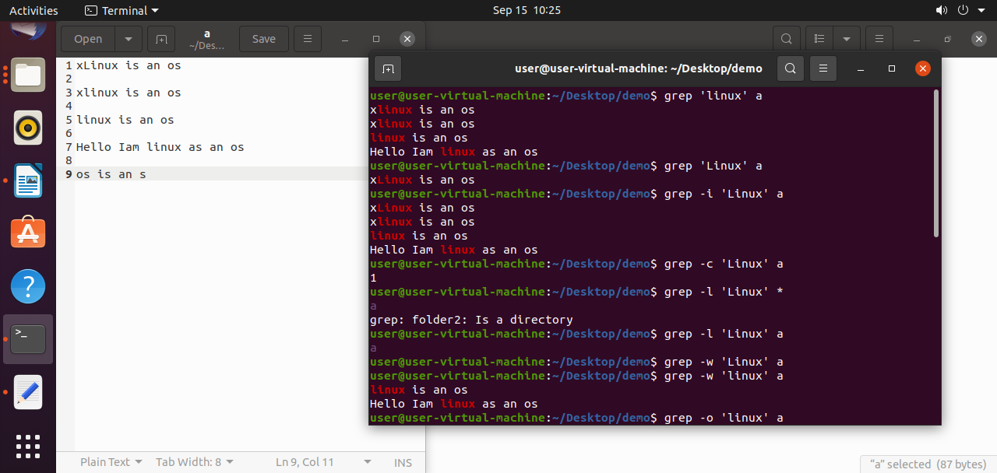

2. grep -i ‘word’ ‘path’ :

Used to find the string without case sensitivity.

3. grep -c ‘word’ ‘path’ :

It counts the word only starting of the line.

4. grep -l ‘word’ *:

Used to find the files and the word present in the file or not.

5. grep -l ‘word’ ‘path’ :

Used to find which file consist the word among them.
6. grep -w ‘word’ ‘path’ :

Used to show fulfledged word in the file.

7. grep -o ‘word’ ‘path’ :

Display only word how many times word present in them.

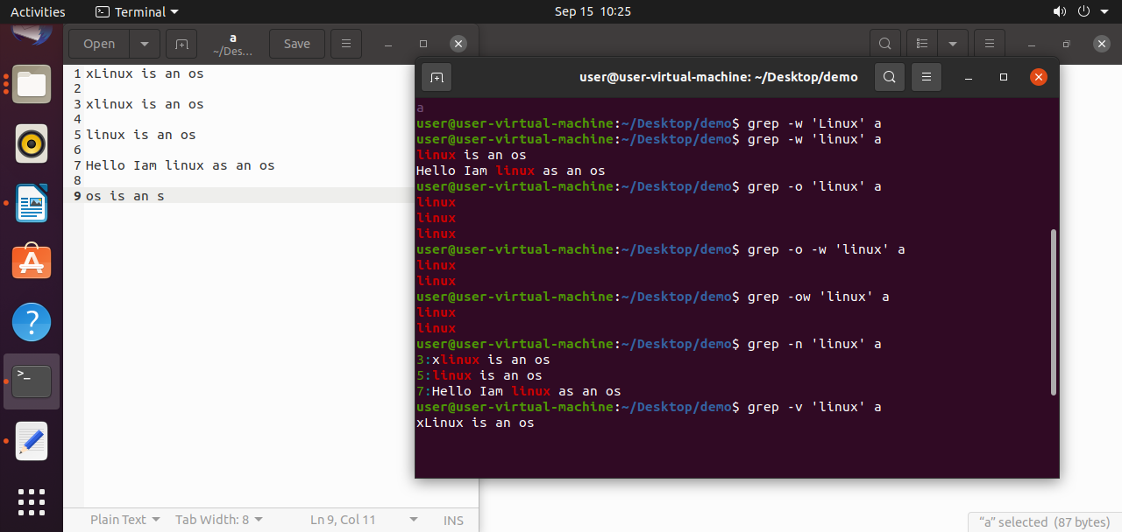
8. grep -o -w ‘word’ filename (or) grep -ow‘word’ filename :

Used to display only exact word present in the file.

9. grep -n ‘word’ filename:

Shows number of lines that word is present in the file.

10. grep -v ‘word’ ‘path’ :

It prints all the lines in which word is not present.

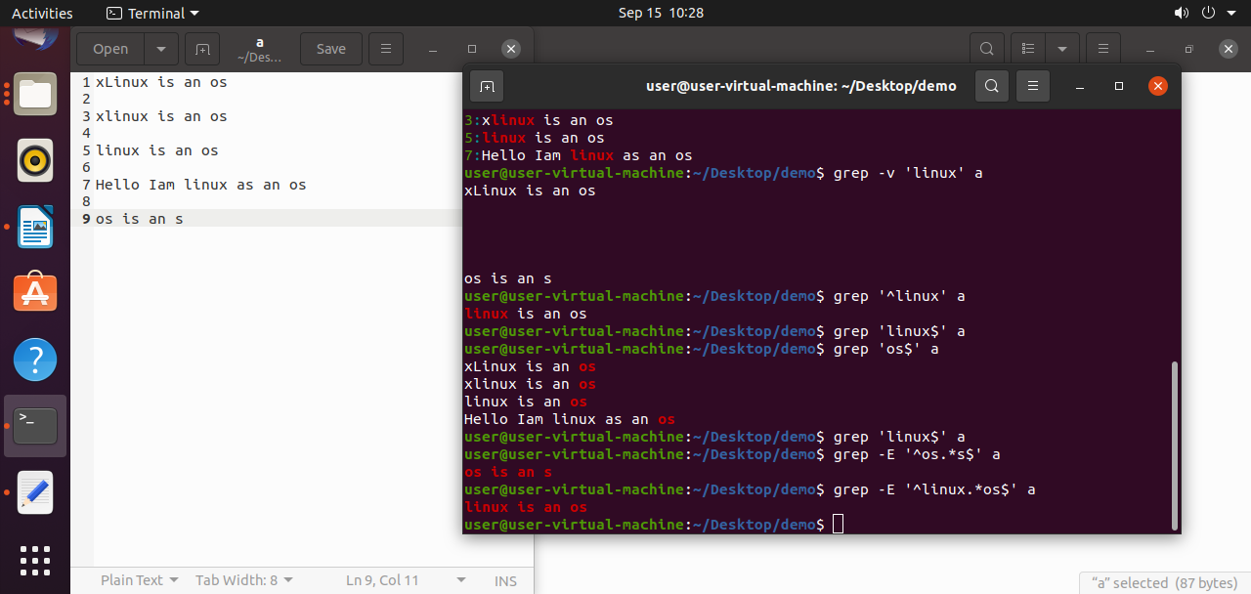
11. grep ‘^word’ filename :

This command is used to check the word at starting in the file.

12. grep ‘word$’ filename :

It will find the word ends with that word present in the file.

13. grep -E ‘^startword.*endword$’ filename :

It will find the line satrts with and ends with same word.

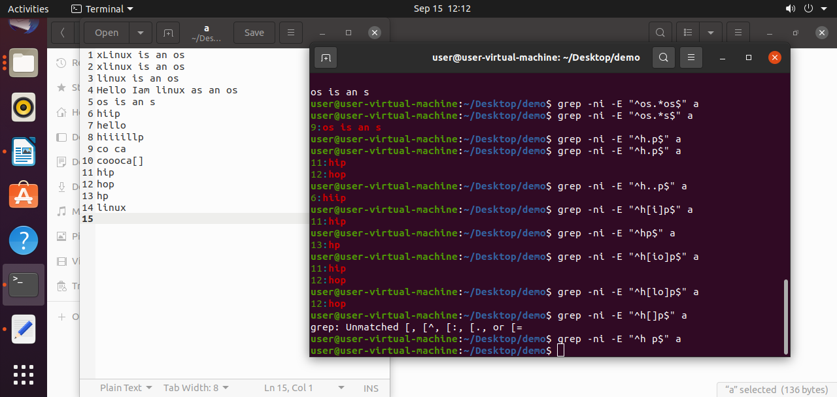
14. cut -c command:

used to cut the words in line.

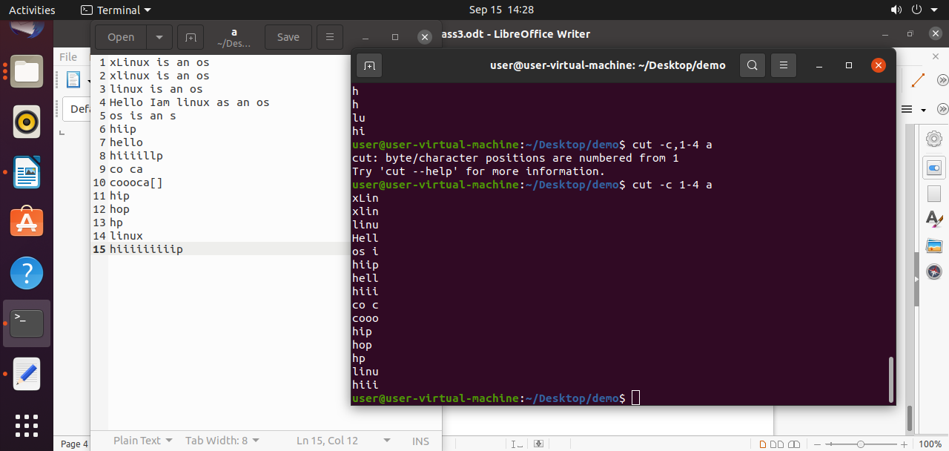
15. cut -b command:

used to cut the byte in file.

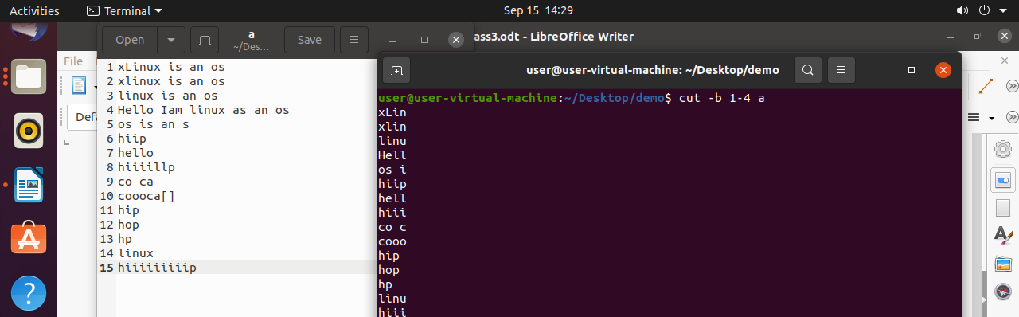
16. cut -d command:

used to print a word until which word it should print.

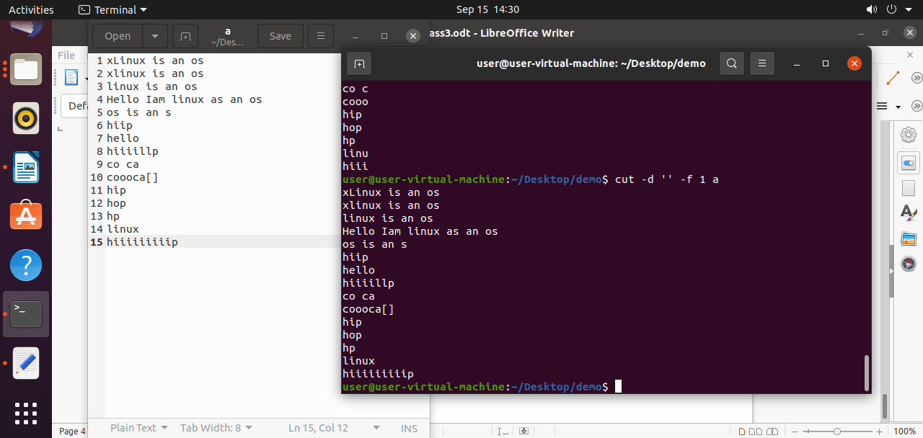

17. grep -ni -E ‘^first letter.lastletter$’ filename:

used to print the word containing 3 letters.

18. grep -ni -E ‘^first letter..lastletter$’ filename:

used to print the word containing 4 letters.

19. grep -ni -E ‘^first letter[i]lastletter$’ filename:

used to print the word which contains 3 letters and middle letter contains i.

20. grep -ni -E ‘^first letter[io]lastletter$’ filename:

used to print the word which contains 3 letters and middle letter contains either i or o.

21. grep -ni -E ‘^first letter[i]+lastletter$’ filename:

used to print the word containing one or more than one ‘i’.

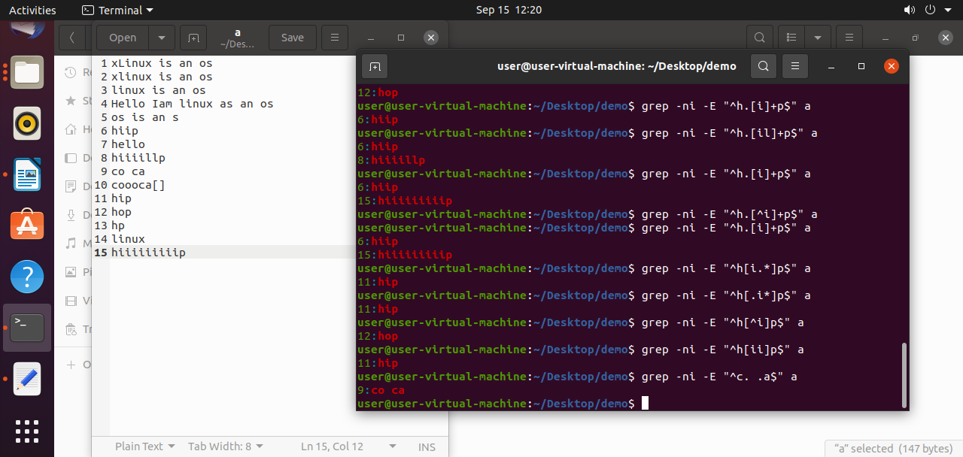

22. grep -ni -E ‘^first letter[^i]+lastletter$’ filename:

used to print the word of 3 letters except i in the middle of word .

23. grep -ni -E “^c. .a$” a:

Used to print the data like co ca.

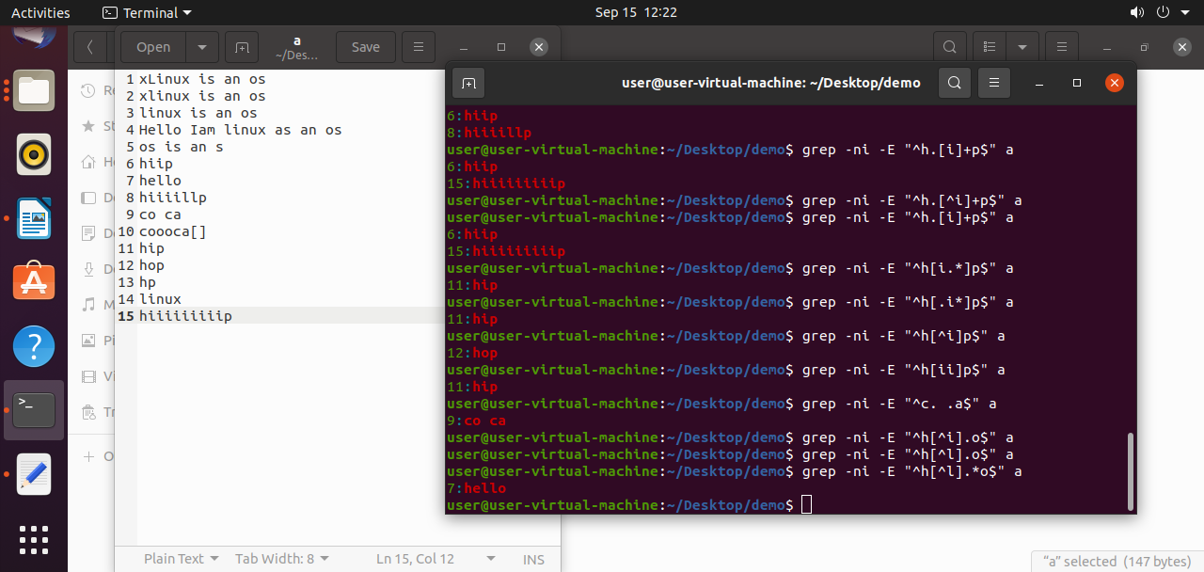

24. cut -c 1 a :

This is used to display the first column.

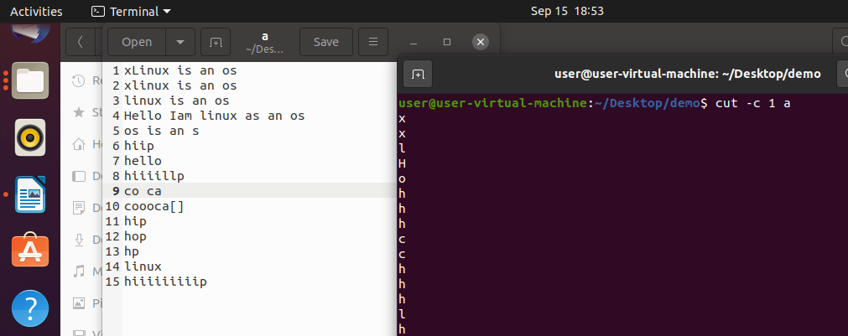
25. cut -c -5 a :

It displays from 1st to 5.
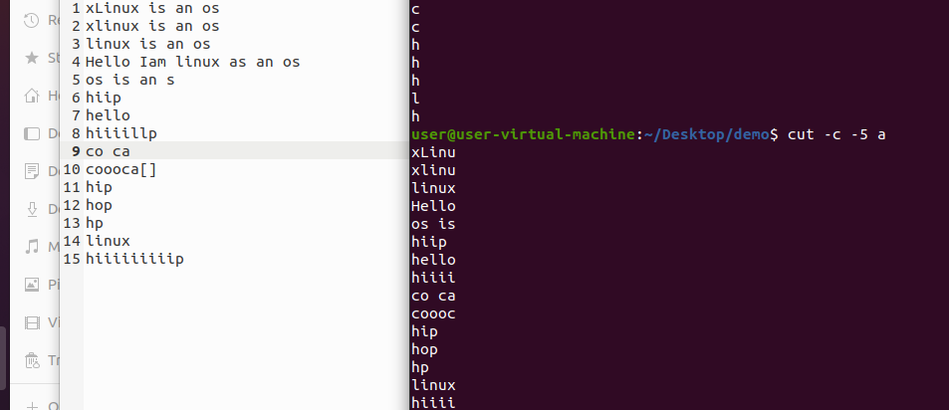

26.cut -d ‘s’ -f 1 a :

It cuts s to next words.

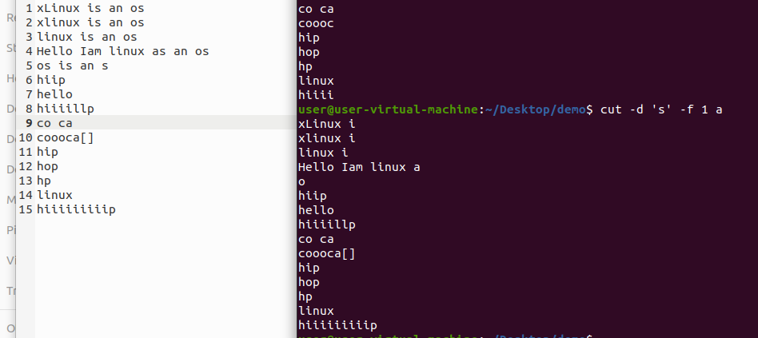

27. cut – complement -c 5- a :

It dispays a word upto 4th letter.

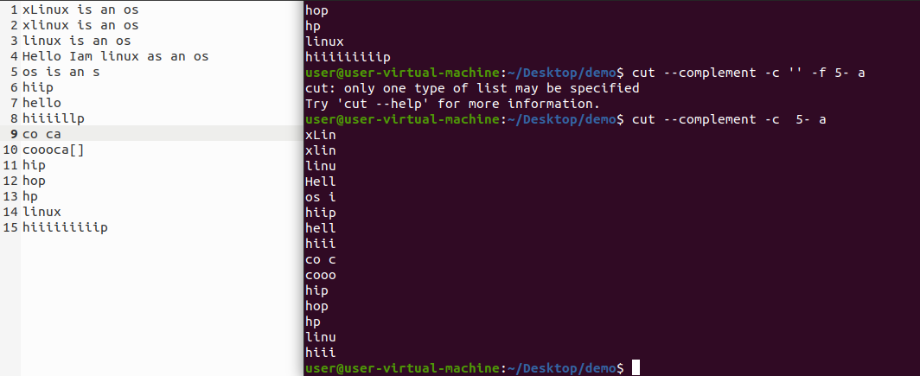

28. cut – complement -d ‘ ’ - f 1 -2 a --output-delimiter = ‘+’ :

It displays the + in delimeter place.

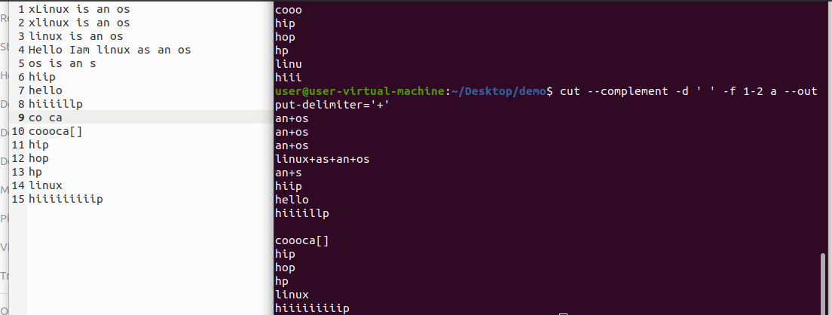

29. cut -d ‘ ’ -f 1 a |sort -r :

It sorts the order in reverse.

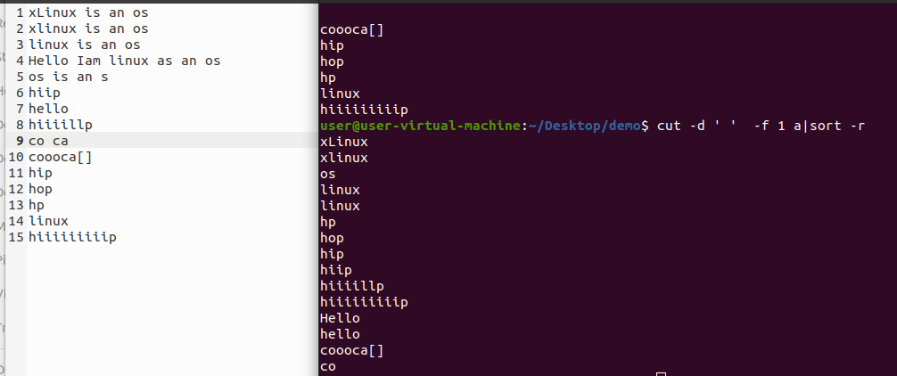

30. cat a |cut -d ‘’ - f 1 – 3|sort -r :

It will sorts the sentences in reverse order.

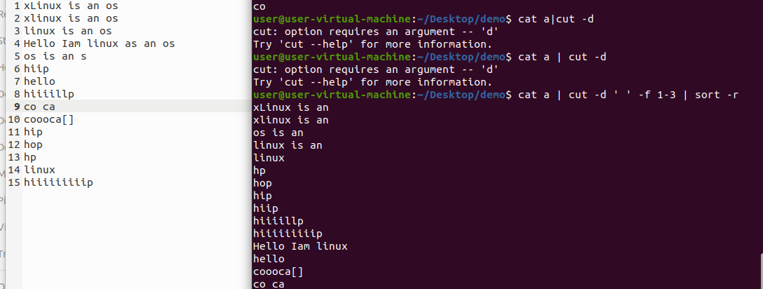

Tr commands:

1. cat ab | tr ‘[a-z]’ ‘[A-Z]’:

It displays lower to upper.

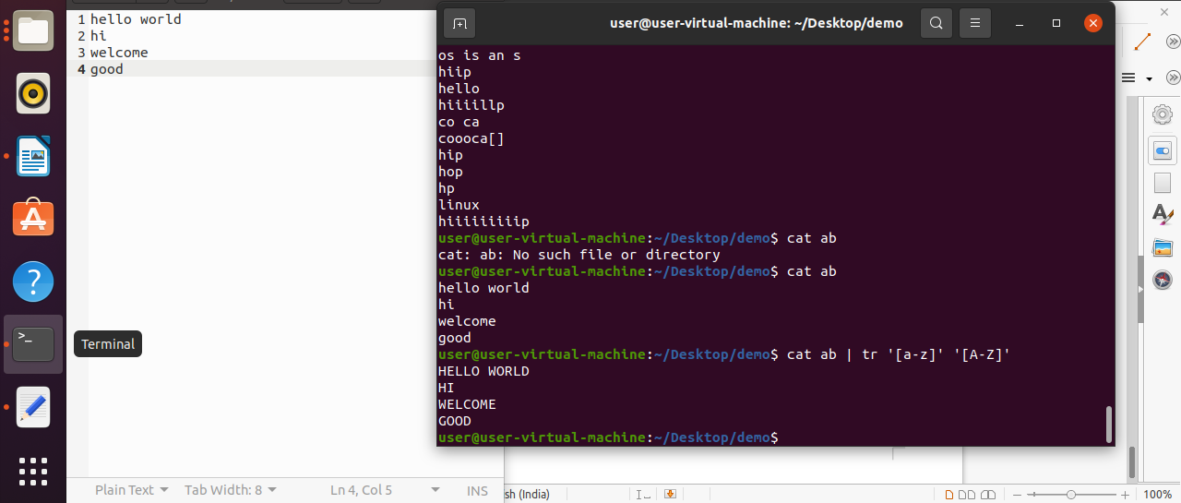

2. cat ab | tr ‘[:space:]’ ‘\n’:

It displays in next line.

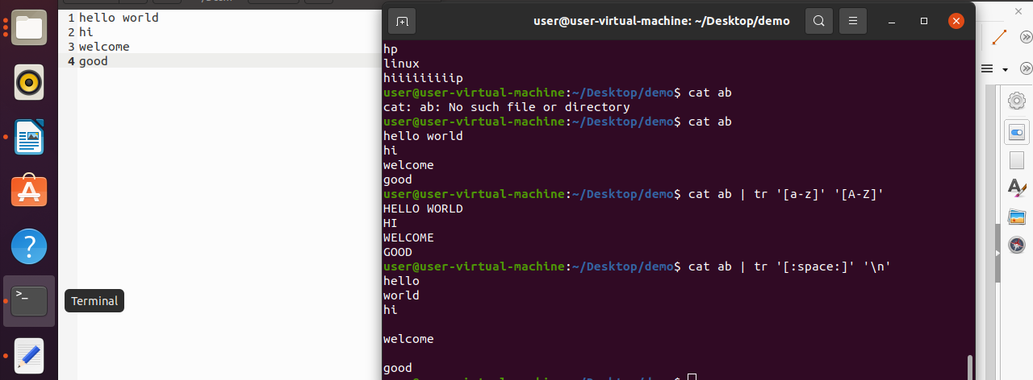

3. cat ab | tr ‘[h]’ ‘[o]’:

It shows o in place of h.
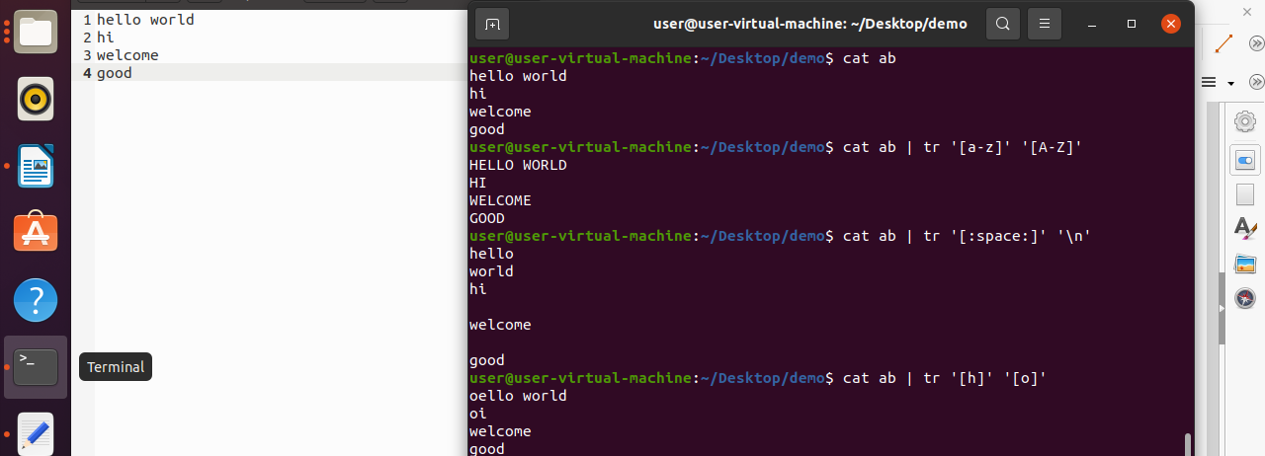
4. cat ab | tr -d ‘[a- i]’ :

It shows only letters in the word except a to i.

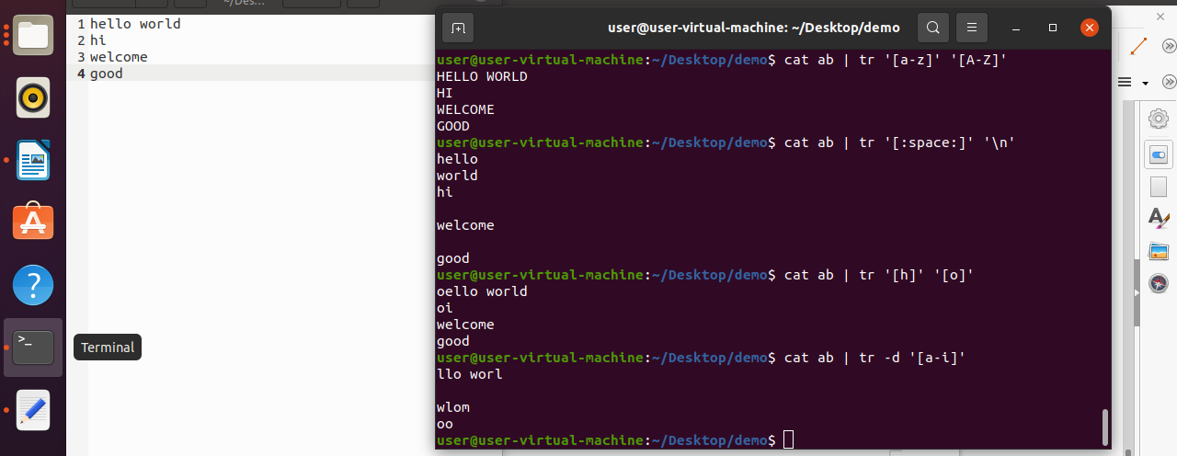

5. cat ab | tr -d ‘[:upper:]’ :

It deletes the upper cases it shows remaining.

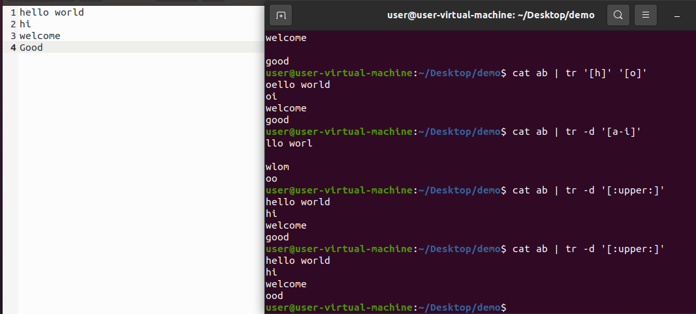
More commands :

1. more a:
It displays all the data present in file a.

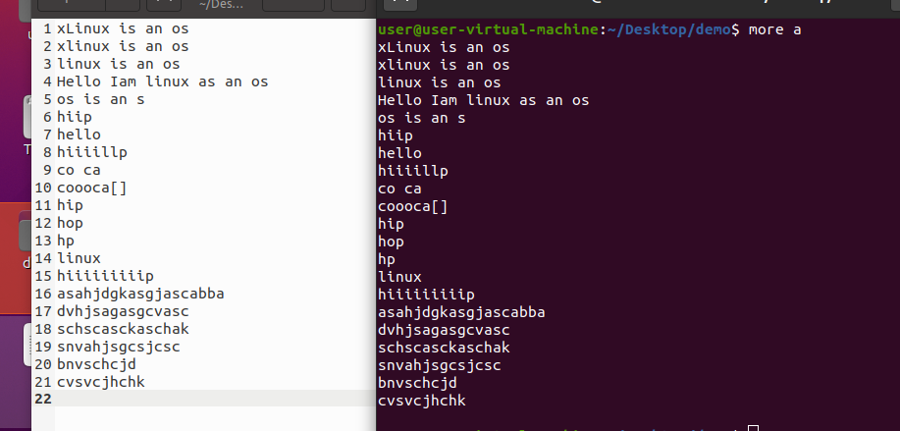

2. more -d a:

Use this command in order to help the use to navigate.

